## LABS

The **Labs** tab is useful in viewing the trend of a condition over time. It is configured in descending timeline order with one result displayed per column, by default. The display may be configured by result type and time.

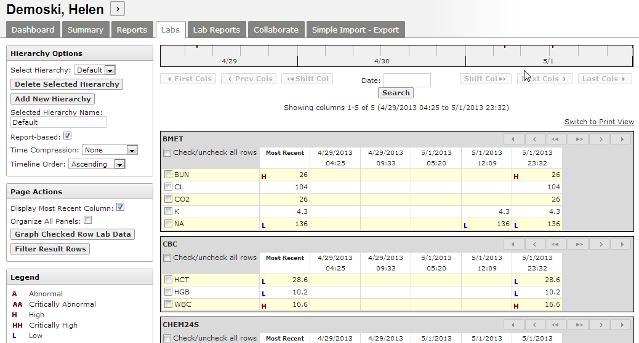

Enter the date into the *Date* box at the top of the screen, or use the calendar to search for results on a specific date. The directional buttons in the top left- and right-hand corners allow you to scroll through the columns of results.

Red tick marks along the top of the timeline represent lab results. Gray shading represents the time period for the columns displayed on screen.



Placing the cursor over a result will display additional details, including any additional values which fall between the min and max values.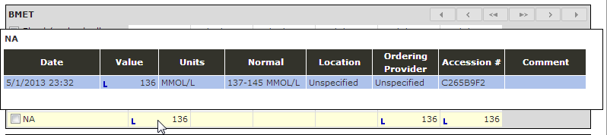

For a printable view of the results displayed, click the **Switch to Print View** in the upper right-hand of the screen. To print, right click anywhere on the screen and use the browser’s print screen capability. To switch back, click **Leave Print View**.

### Hierarchy Options

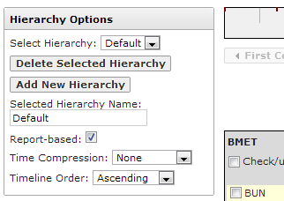The *Hierarchy Options*section allow users to customize the sequence and grouping of the **Labs** display.

* Select adisplay hierarchy from the *Select* Hierarchy dropdown box.
* Once selected, a hierarchy can be deleted by clicking **Delete Selected Hierarchy.** Click **Add New Hierarchy** to create your own configuration.
* Checking the **Report-based** box organizes labs as they were ordered/resulted (i.e. in a Report form), not by the selected hierarchy. For example, checking this box groups related analytes, such as Hemoglobin, Hematocrit, and WBCs together. If unchecked, the labs will appear per the hierarchy options.
* **Time compression** may be set to daily, weekly, monthly, quarterly, or yearly. Greater time compression (e.g. quarterly or yearly) might be more helpful in tracking the progression of a disease of longer periods of time, while a lesser time compression (daily or weekly) would be more appropriate when viewing results from an acute episode or single encounter. Note: If a specific lab result exists more than once during the selected time compression, the row will show the min and max values of that lab result during that time period.
* **Timeline Order** can be set as ascending or descending from left to right.

### Page Actions and Panel Shortcuts

Page Actions allow users to customize their current view of Labs. Panel Shortcuts facilitate navigation.

* 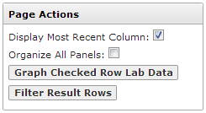Checking **Display Most Recent Column** inserts a column with the most recent result of each lab panel currently displayed to the left of all columns.
* **Organize All Panels** allows drag-and-drop organization of the lab panels. For example, after checking this box, you can grab the CBC Basic panel with your mouse and move it to a lower position.
* Graphing lab results is possible by checking at least one box for a panel or the individual items within a panel and then clicking the **Graph Checked Row Lab Data** button.
* **Filter Result Rows** allows users to filter by a search term, such as “blood.” After searching for this term, only results with “blood” in the name of the lab will be displayed. After viewing the filtered results, click on the **Remove Filter** button that is displayed above the first lab panel.
* Clicking on any of the **Panel Shortcuts** in the lower left-hand corner of the page will take you directly to the desired panel, instead of scrolling through the panels displayed above it.